**DAY 6 LAB EXPERIMENTS**

**1. To Implement the Median of Medians algorithm ensures that you handle the worst-case**

**time complexity efficiently while finding the k-th smallest element in an unsorted array.**

**arr = [12, 3, 5, 7, 19] k = 2 Expected Output:5**

**arr = [12, 3, 5, 7, 4, 19, 26] k = 3 Expected Output:5**

**arr = [1, 2, 3, 4, 5, 6, 7, 8, 9, 10] k = 6 Expected Output:6**

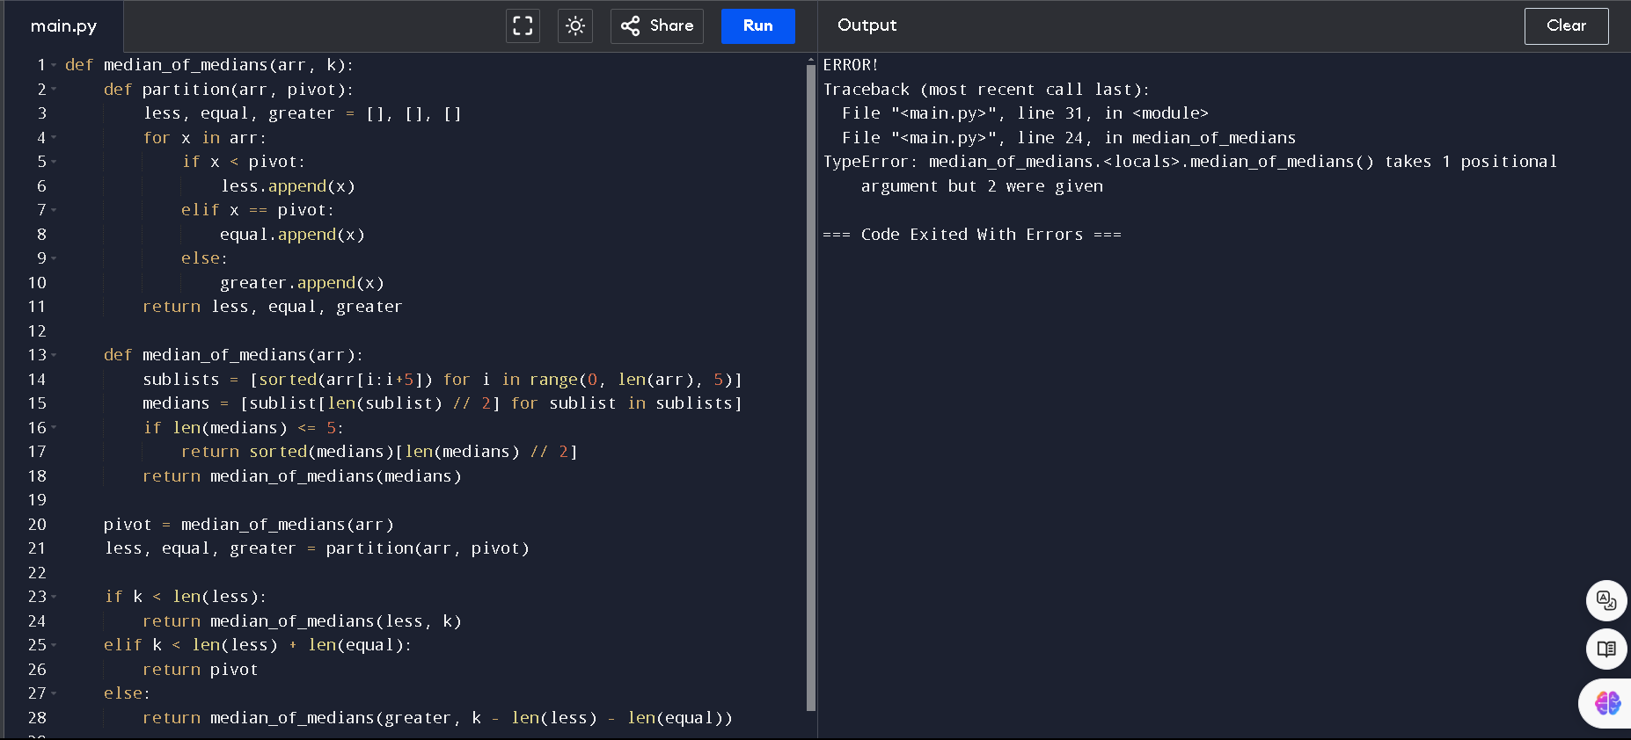

**2. To Implement a function median_of_medians(arr, k) that takes an unsorted array arr and an**

**integer k, and returns the k-th smallest element in the array.**

**arr = [1, 2, 3, 4, 5, 6, 7, 8, 9, 10] k = 6**

**arr = [23, 17, 31, 44, 55, 21, 20, 18, 19, 27] k = 5**

**Output: An integer representing the k-th smallest element in the array.**

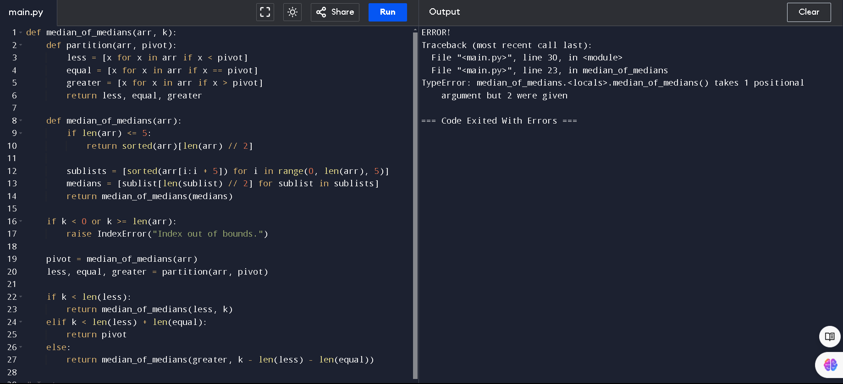

**3. Write a program to implement Meet in the Middle Technique. Given an array of integers**

**and a target sum, find the subset whose sum is closest to the target. You will use the Meet**

**in the Middle technique to efficiently find this subset.**

**a) Set[] = {45, 34, 4, 12, 5, 2} Target Sum : 42**

**b) Set[]= {1, 3, 2, 7, 4, 6} Target sum = 10:**

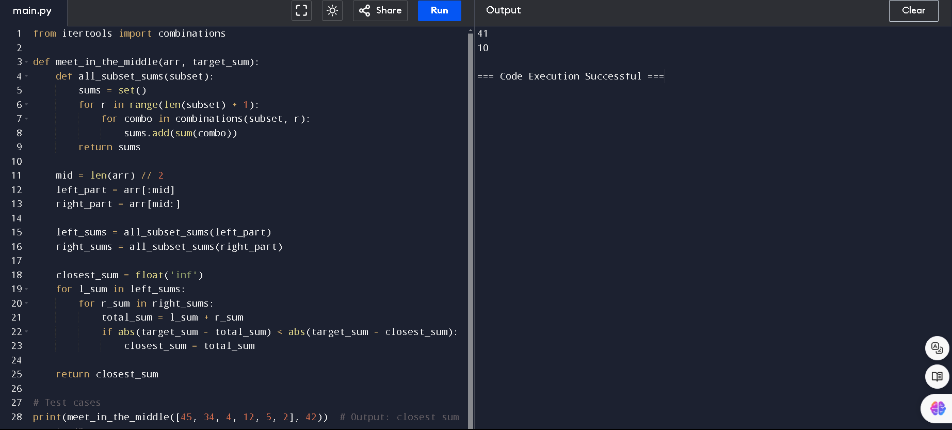

**4. Write a program to implement Meet in the Middle Technique. Given a large array of**

**integers and an exact sum E, determine if there is any subset that sums exactly to E. Utilize**

**the Meet in the Middle technique to handle the potentially large size of the array. Return**

**true if there is a subset that sums exactly to E, otherwise return false.**

**a) E = {1, 3, 9, 2, 7, 12} exact Sum = 15**

**b) E = {3, 34, 4, 12, 5, 2} exact Sum = 15**

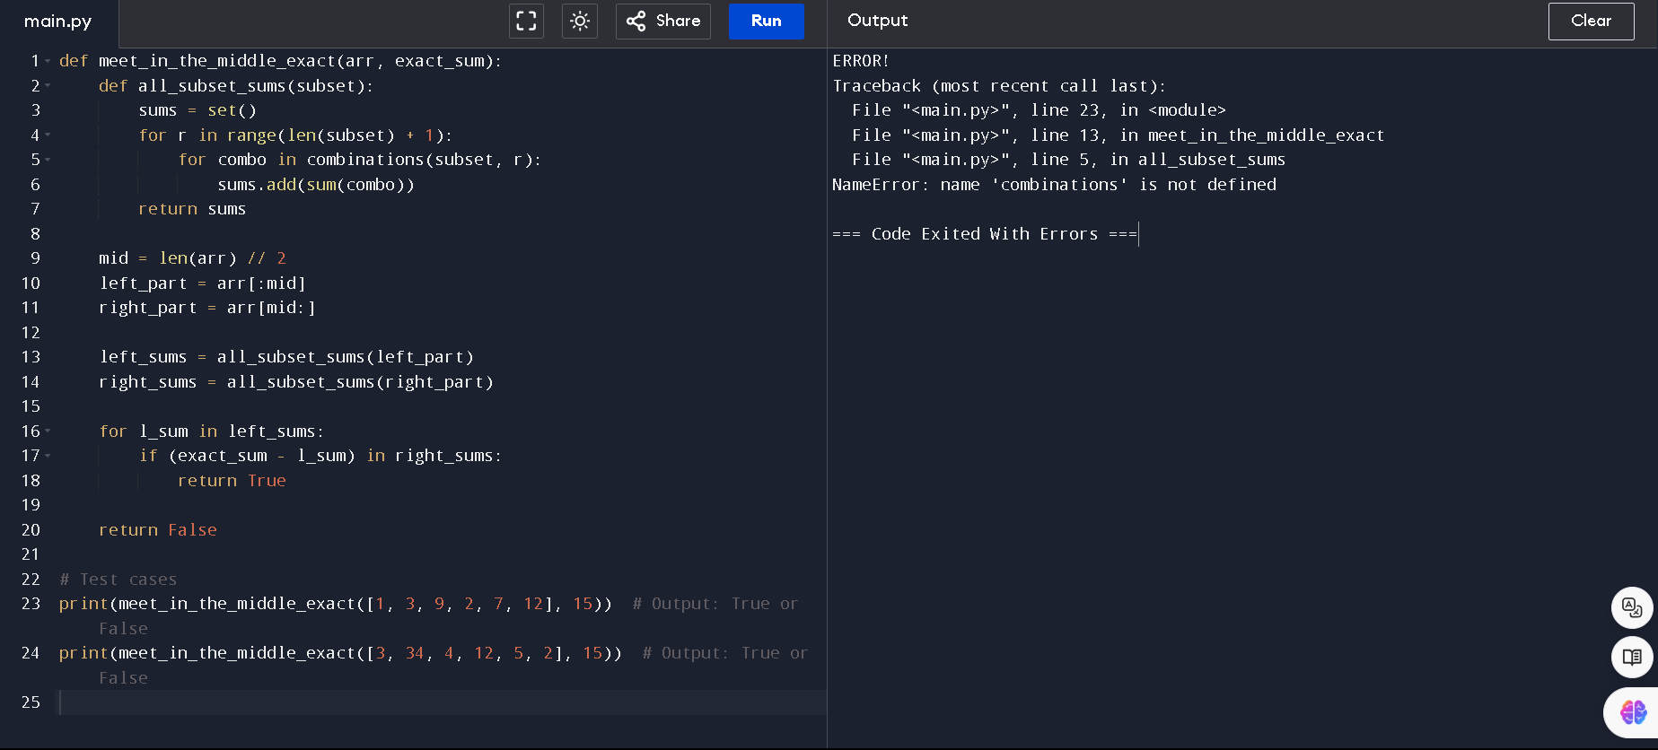

**5. Given two 2×2 Matrices A and B**

**A=(1 7 B=( 1 3**

**3 5) 7 5)**

**Use Strassen's matrix multiplication algorithm to compute the product matrix C such that**

**C=A×B.**

**Test Cases:**

**Consider the following matrices for testing your implementation:**

**Test Case 1:**

**A=(1 7 B=( 6 8**

**3 5), 4 2)**

**Expected Output:**

**C=(18 14**

**62 66)**

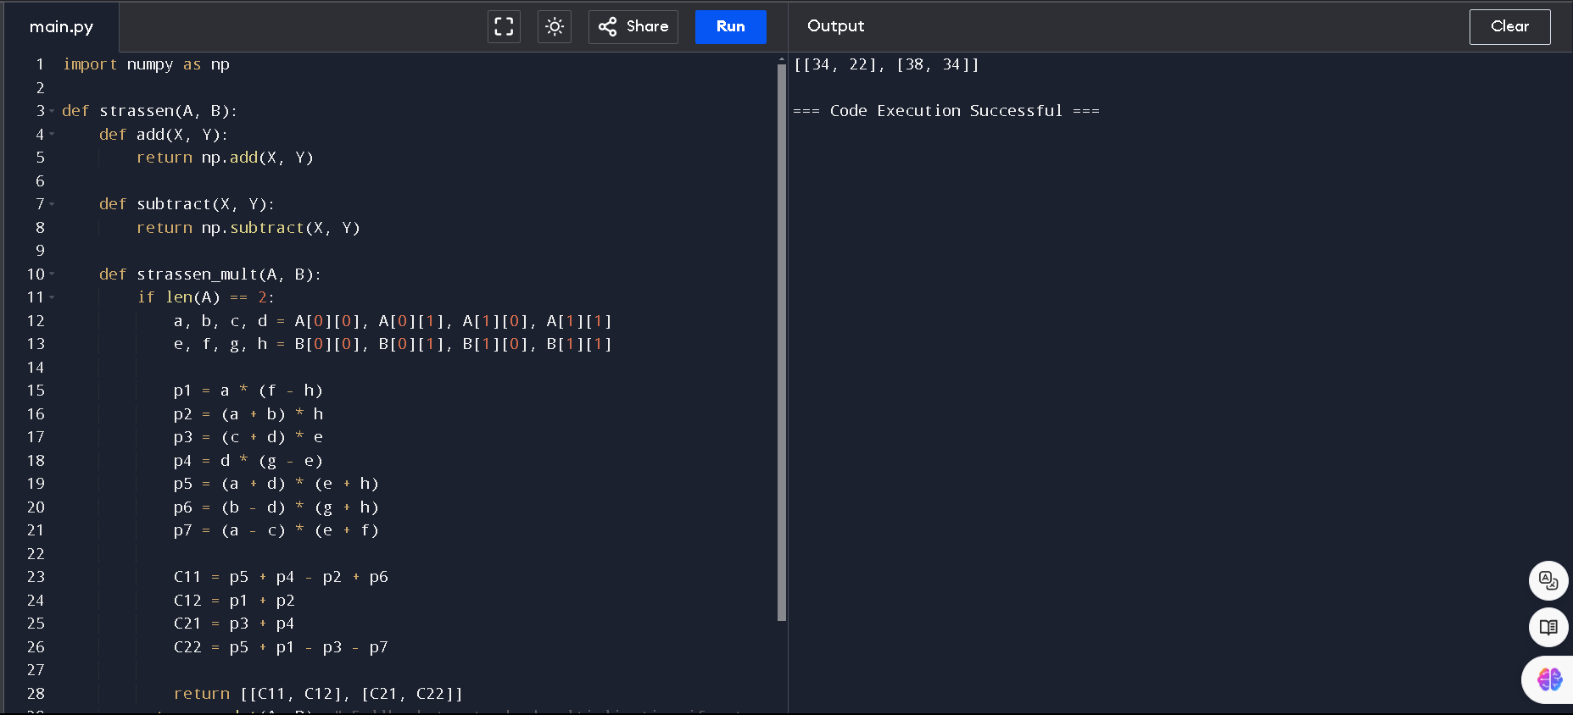

**6. Given two integers X=1234 and Y=5678: Use the Karatsuba algorithm to compute the**

**product Z=X x Y**

**Test Case 1:**

**Input: x=1234,y=5678**

**Expected Output: z=1234×5678=701665**

